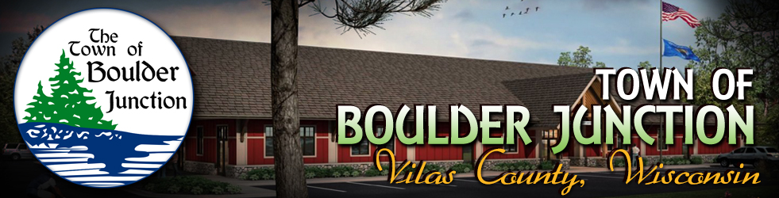

Notice of Boulder Junction Economic Development/Connect Communities Committee Meeting
Thursday, March 1, 2018
9:00 a.m.
Boulder Junction Community Center, Nordlof Room
5392 Park Street, Boulder Junction, WI 54512

AGENDA

- CALL TO ORDER - PLEDGE OF ALLEGIANCE - ROLL CALL
- APPROVAL OF THE AGENDA (discussion & possible action)
- APPROVAL OF FEBRUARY 1 MEETING MINUTES (discussion & possible action)
- WELCOME GUEST(S): At this time guest(s) may address the committee regarding Agenda items
- UNFINISHED BUSINESS (discussion &possible action)
- Choice Tel & Sonic Net responses from Barry McLeane
b) Student Survey
- Final analysis
c) Snow Removal Discussion
d) WEDC Suggestions
- Strategic Doing
6) NEW BUSINESS (discussion & possible action)
a) Discussion regarding future projects and goals of BJED/CC Committee
7) CONFIRM DATE, TIME AND LOCATION OF NEXT MEETING (discussion & possible action)
8) ADJOURN (discussion & possible action)

Posted by Clerk/Treasurer Kendra Moraczewski on behalf of Chairperson Colleen Swanson

Postings: Official: Community Center and Website: www.townofboulderjunction.org
Courtesy: Hogan’s General Store

