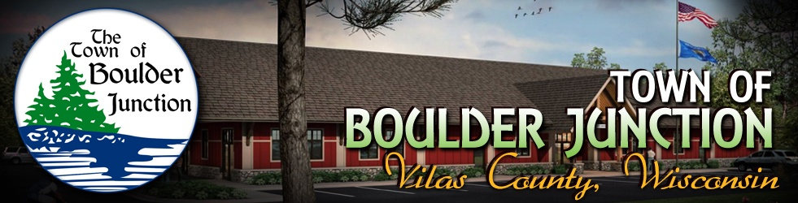

Notice of Boulder Junction Economic Development/Connect Communities Committee Meeting
Wednesday, May 1, 2019
9:00 a.m.
Boulder Lake Room
5392 Park Street, Boulder Junction, WI 54512
Our Mission: To explore, develop and promote opportunities and investment options supporting our economic development objectives while enhancing community prosperity.

AGENDA

- CALL TO ORDER - PLEDGE OF ALLEGIANCE - ROLL CALL
- APPROVAL OF THE AGENDA (discussion & possible action)
- APPROVAL OF APRIL 3, 2019 MEETING MINUTES (discussion & possible action)
- WELCOME GUEST(S): At this time guest(s) may address the committee regarding Agenda items
- UNFINISHED BUSINESS (discussion & possible action)
  - Expansion of affordable broadband and high speed internet access – Workgroup update
  - Seasonal & Long-Term Housing – Workgroup update
  - Build Your Boulder Business – report on 04/24/2019 Social Media Workshop, 2019 schedule and Workgroup update
  - Monthly report on Committee Expenses and Committee Budget
  - Monthly Connect Communities reporting
  - Report on Destination Development Association 04/10/2019 webinar and schedule
  - “Welcome To Boulder Junction” materials for prospective & new businesses and residents and Workgroup creation
  - Public Restrooms within Main Street District – Workgroup update
- NEW BUSINESS (discussion & possible action)
  - Committee’s 2018 Annual Report to the Electors
  - Resignation of Laura Bertch from Committee/Acknowledge new Committee members/Appointment of Committee Secretary
- REQUEST FOR FUTURE AGENDA ITEM (no discussion & no possible action)
- CONFIRM DATE, TIME AND LOCATION OF NEXT MEETING (discussion & possible action)
- PUBLIC VIEWING OF DESTINATION DEVELOPMENT ASSOCIATION WEBINAR “RESTROOMS ATTRACT A LOT MORE THAN FLIES” (discussion & possible action)
- ADJOURN (discussion & possible action)

A quorum of town board members may be in attendance at this meeting for information gathering purposes only and only committee action will be taken at this meeting.

Posted by Clerk/Treasurer Dan Driscoll on behalf of Committee Chairman Dennis Aukstik

Postings: Official: Community Center and Website: www.townofboulderjunction.org
Courtesy: Hogan’s General Store

