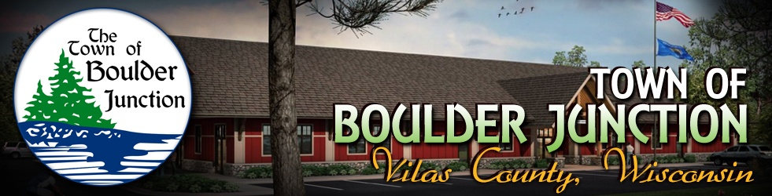

Notice of Boulder Junction Economic Development/Connect Communities Committee Meeting
Wednesday, January 8, 2020
9:00 a.m.
Nordlof Room
5392 Park Street, Boulder Junction, WI 54512
Our Mission: To explore, develop and promote opportunities and investment options supporting our economic development objectives while enhancing community prosperity.

AGENDA

- CALL TO ORDER - PLEDGE OF ALLEGIANCE - ROLL CALL
- APPROVAL OF THE AGENDA (discussion & possible action)
- APPROVAL OF December 4, 2019 MEETING MINUTES (discussion & possible action)
- WELCOME GUEST(S): At this time guest(s) may address the committee regarding Agenda items
- UNFINISHED BUSINESS (discussion & possible action)
  - Expansion of affordable broadband and high speed internet access – report on status
  - Build Your Boulder Business – update and report on 2020 schedule
  - Report on Destination Development Association 12/11/2019 webinar and 2020 webinars
  - Monthly report on Committee Expenses/ Committee Budget
  - Monthly Connect Communities reporting
  - Telecommuter Forward! Community Certification Program – report on activities
  - Report on proposed Public Restrooms
  - Report on Business Recruitment & Development Marketing Materials
- NEW BUSINESS (discussion & possible action)
  - Appointment of Matt Ashley to ED/CCC
  - Effect of climate change upon economic development in Boulder Junction
- REQUEST FOR FUTURE AGENDA ITEM (no discussion & no possible action)
- CONFIRM DATE, TIME AND LOCATION OF NEXT MEETING (discussion & possible action)
- ADJOURN (discussion & possible action)

A quorum of town board members may be in attendance at this meeting for information gathering purposes only and only committee action will be taken at this meeting.

Posted by Clerk/Treasurer Dan Driscoll on behalf of Committee Chairman Dennis Aukstik

Postings: Official: Community Center and Website: www.townofboulderjunction.org
Courtesy: Hogan’s General Store

